CDA 3103
Spring 2002
Lab #2
Due: Tuesday 4/02/02

This laboratory will use the 74151 chip (which is an 8:1 mux, under the 7400DEVS.CLF library of LogicWorks) and the hex keyboard device (which is under the PRIMIO.CLF library of LogicWorks in version 3 and SimulationIO.CLF in version 4).

The textbook, when defining functions or chips, usually uses "A" as the high order (most significant) bit. The 151 mux, on the other hand, uses "A" as the low order (least significant) bit. This assignment will be described following the 151-chip format, i.e., "A" will be the low order bit.

Consider the following two functions:

D C B A | F1 F2
--------------+---------
0 0 0 0 | 1 0
0 0 0 1 | 1 1
|
0 0 1 0 | 1 1
0 0 1 1 | 0 0
|
0 1 0 0 | 0 1
0 1 0 1 | 1 0
|
0 1 1 0 | 0 1
0 1 1 1 | 0 1
|
1 0 0 0 | 0 0
1 0 0 1 | 1 0
|
1 0 1 0 | 1 0
1 0 1 1 | 1 1
|
1 1 0 0 | 1 1
1 1 0 1 | 0 1
|
1 1 1 0 | 0 0
1 1 1 1 | 0 0
|

Implement the above two functions using two 151 chips, i.e., each function is implemented using a 151 chip. As explained in the textbook and discussed in class, you need to group adjacent pairs of the truth table rows to implement a 4-input function using an 8:1 mux.

Use a hex keyboard device to produce the 4 input bits.
Note that:
- You need to connect the high order bit ("D") of the hex keyboard to "C" of each 151 mux, you need to connect the second high order bit ("C") of the keyboard to "B" of each mux, and you need to connect the third high order bit ("B") of the keyboard to "A" of each mux, as shown in the figure below.
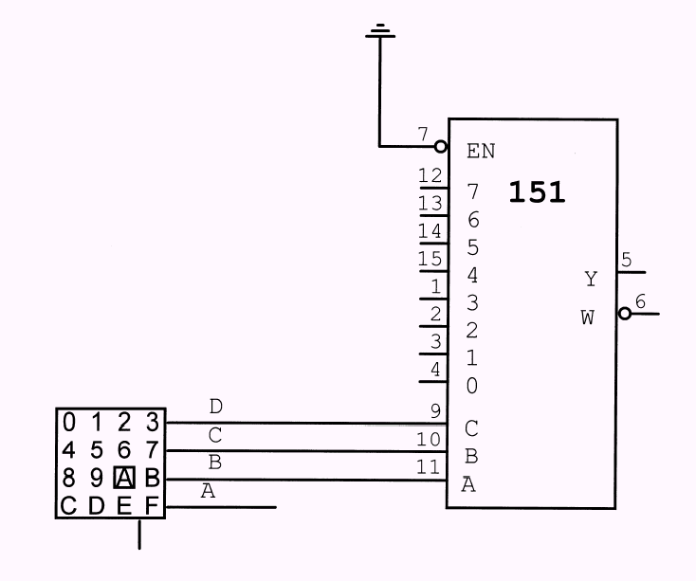

- You need to use the fourth high order bit (i.e., the low order bit - "A") of the keyboard, "0" (ground) and "1" (+5v) as the eight inputs to each mux.

- You need to connect the enable input EN of each mux chip to ground in order to enable the device.

As in previous labs, you must label the input signals and the output signals. You must also include a text-box on the design with your name and social security number.

Simulate your design by entering digits as inputs. Press the hex keyboard for each digit. Avoid any glitches by entering the sequence of binary values for D, C, B and A such that each sequence differs from its predecessor by exactly 1 bit. You are supposed to use 16 input configurations. One possible order is 0000, 0001, 0011, 0010, 0110, 0111, 0101, 0100, 1100, 1101, 1111, 1110, 1010, 1011, 1001, 1000. Use the corresponding hex digits for this sequence.

What To Turn In:

- A hard copy (generated from LogicWorks) of the schematics.
- A hard copy (generated from LogicWorks) of the simulation.
- A disk containing your file for LogicWorks.

